**Department of Information Technology**

**Academic Year: 2024-25 Name of Student:**

**Semester: VI Student ID:**

**Class / Branch / Div: TE- IT A/B/C Roll No.**

**Subject: MAD & PWA Lab Date of Submission:**

**Name of Instructor: Prof. Sujata Oak**

**Experiment No.:3**

**Aim:** To design a layout of Flutter App using layout widgets.

**Prerequisites:** Android studio, flutter SDK **.**

**Problem Statement:** To develop a flutter UI for creating List View using Layout widgets of flutter.

**Software:** Android studio, flutter SDK **.**

**Implementation:**

import 'package:flutter/material.dart';  
  
void main() {  
 runApp(MyApp());  
}  
  
class MyApp extends StatelessWidget {  
 @override  
 Widget build(BuildContext context) {  
 return MaterialApp(  
 debugShowCheckedModeBanner: false,  
 home: Scaffold(  
 appBar: AppBar(title: Text("Product List")),  
 body: ListView(  
 children: [  
 Expanded(child:  
 ProductBox(  
 name: "Smartphone",  
 description: "A high-quality smartphone with great camera features.",  
 price: 699,  
 image: "assets/smartphone.png",  
 ),),  
  
 Expanded(child:  
 ProductBox(  
 name: "Headphones",  
 description: "Wireless noise-canceling headphones.",  
 price: 199,  
 image: "assets/headphone.png",  
 ),),  
  
 Expanded(child:  
 ProductBox(  
 name: "Smartwatch",  
 description: "A sleek smartwatch with fitness tracking features.",  
 price: 299,  
 image: "assets/smartwatch.png",  
 ),),  
  
 Expanded(child:  
 ProductBox(  
 name: "Tablet",  
 description: "A tablet is a wireless, portable personal computer with a touchscreen interface.",  
 price: 30000,  
 image: "assets/tablet.png",  
 ),),  
 ],  
 ),  
 ),  
 );  
 }  
}  
  
class ProductBox extends StatelessWidget {  
 final String name;  
 final String description;  
 final int price;  
 final String image;  
  
 ProductBox({required this.name, required this.description, required this.price, required this.image});  
  
 @override  
 Widget build(BuildContext context) {  
 return Container(  
 padding: EdgeInsets.all(10),  
 margin: EdgeInsets.all(10),  
 decoration: BoxDecoration(  
 border: Border.all(color: Colors.*grey*),  
 borderRadius: BorderRadius.circular(10),  
 color: Colors.*white*,  
 ),  
 child: Row(  
 children: [  
 Image.asset(image, width: 100, height: 100, fit: BoxFit.cover),  
 SizedBox(width: 10), *// Space between image and text* Expanded(  
 child: Column(  
 crossAxisAlignment: CrossAxisAlignment.start,  
 children: [  
 Text(name, style: TextStyle(fontSize: 18, fontWeight: FontWeight.*bold*)),  
 SizedBox(height: 5),  
 Text(description, style: TextStyle(fontSize: 14, color: Colors.*grey*[600])),  
 SizedBox(height: 5),  
 Text("\$${price.toString()}", style: TextStyle(fontSize: 16, fontWeight: FontWeight.*bold*, color: Colors.*green*)),  
 ],  
 ),  
 ),  
 ],  
 ),  
 );  
 }  
}

**pubspec.yaml**

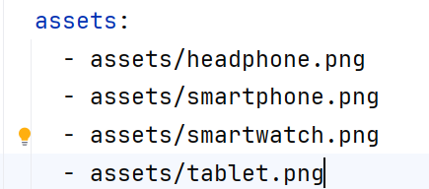

**Output:**

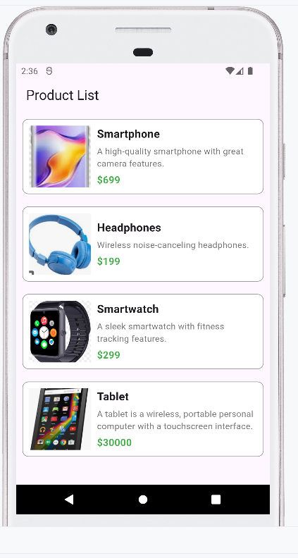

**Conclusion:** In this experiment we have designed a layout by using flutter various layout widgets.